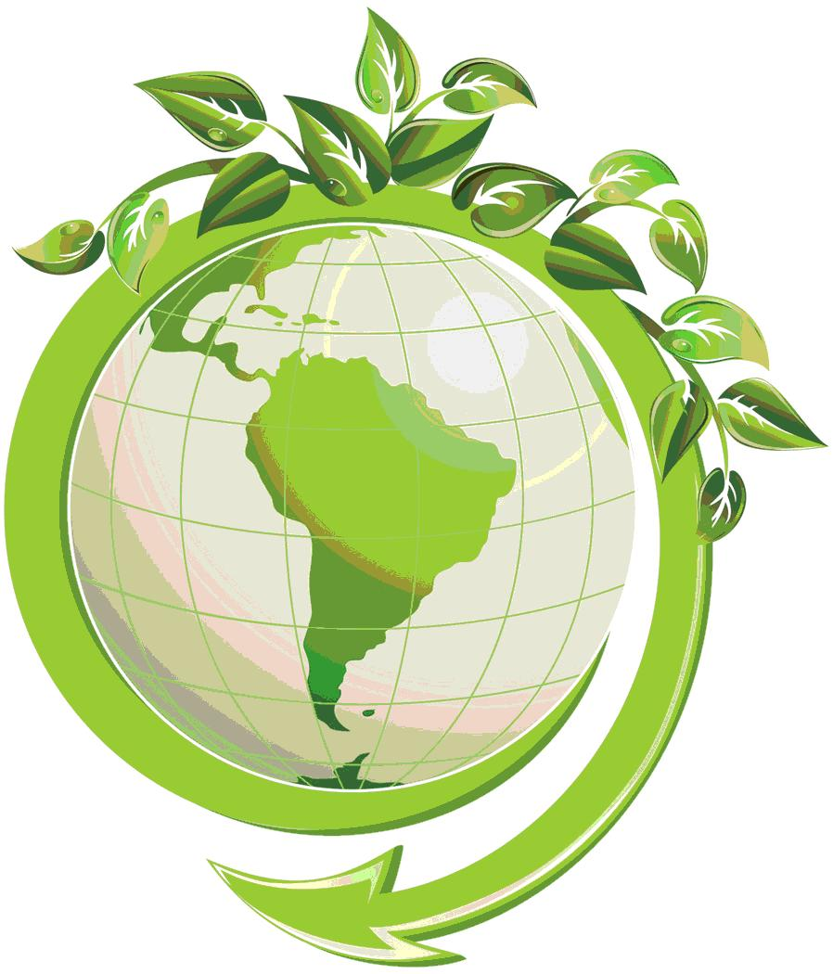
Lesson Plan
Green Day

Timing: Day A, Activity 3

Materials Needed: Scrap paper and blank white paper
3 videos sent over email from Megan Icenogle labeled
“RRR guidelines within BBES”

Main Activity: Learn more about recycling and reusing at BBES (in the classroom and in the cafeteria)

Opening: Explain the concept:
BBES is working to reduce, reuse and recycle! Our GREEN TEAM is helping to lead us in this mission. Last year, we reduced our trash in the cafeteria by about 40% during our recycling focus time. We went from 15 bags of trash per day out of the cafeteria to 9 bags of trash per day. Let’s do better!!!

We’re going to watch some instructional videos on recycling.

Lesson: Watch videos: which consist of a classroom recycling guide, a cafeteria recycling guide, and a video “quiz” to see what students remember.

ASK: After video 1, turn and talk to a partner, what did you learn?

ASK: After video 2, turn and talk to a partner, what did you learn?

TELL: In this video, a member of the Green Team will hold up an item. It’s your job to respond to the screen how the item should be handled. Should it be: REUSED, RECYCLED, or put in the TRASH? If it is recycled, where so (Terracycle, classroom bin, cafeteria recycle bin, etc)?

Closing: Review/create goals for classroom and cafeteria practices.

Product: If you make any classroom goals, Mrs. Icenogle and the Green Team would love a copy of whatever you create- or just an email letting the Green Team know!!

